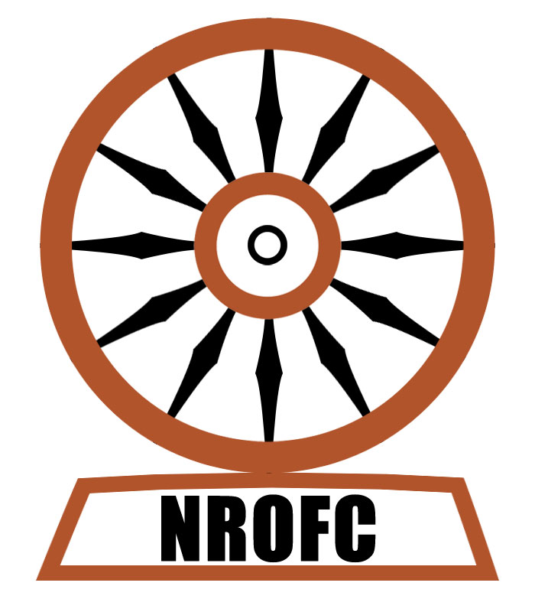


Non-Resident Oriya Facilitation Center

Regd. no. 22034/15 of 2005-06 of Orissa under Registration of Societies Act 1860
D-3, B. J. B. Nagar, Bhubaneswar 751014 (0674 2432251)

Sub: Symposium on ‘Odisha Vikash’ on 5th Pravasi Oriya Diwas on Dec. 21, 2008 at Bhubaneswar

Dear Friends,

On behalf of the NRO Cell of the Government of Orissa and the Non-Resident Oriya Facilitation Center, we invite you to participate in the Fifth Pravasi Oriya Diwas and the 5th Annual Symposium on Orissa Development, to be inaugurated at Nine Thirty in the morning on December 21st, 2008 at NALCO Community Centre, Nalco Nagar, (Beside Kalinga Hospital) Bhubaneswar. The tentative programme schedule is given below.

We will hold a symposium on Odisha Vikash, in partnership with SEEDS (Sustainable Economic and Educational Development Society) and Human Development Foundation (HDF). The idea is to use the platform, where representatives from the government will be present, to spark debate on various development related issues concerning the state and make some recommendations for the government to accept and act. (Concept paper attached)

Papers on various themes Governance, Education, Health and IT, Industry and Infrastructure will be presented by various experts. The list of papers (tentative) on various themes to be presented is given below

Since the Government does not make any financial contribution to the NROFC function though they actively support it, we keep small registration fees to cover the food and snacks cost.

The registration fees for Resident Odias are:

- Rs 150/- to cover the cost of snacks and lunch
- Rs 250/- to cover the cost of snacks, lunch and dinner (After the symposium on ‘Orissa Vikash’ is over, there will be cultural programme in the evening followed by dinner)

The registration fee for Non Resident Odias (NROs) is: $25 or Rs 1,000

A small registration form is attached for you to fill and send us before 18th December 2008 confirming your participation in the conference. That will help us to assess the total number of participants and make arrangements accordingly.

For further query, please contact, Pradeep Baisakh, Convener of conference, in e mail id: 2006pradeep@gmail.com and mobile no: 09437112061

We look forward to hearing from you soon with your itinerary

With our best regards,
Yours sincerely

Sahadeva Sahoo, (President, NROFC)
Chittaranjan Das, (Secretary, NROFC)
Bijay Patra, (Treasurer, NROFC)
website at www.nrofc.org
write to secretarynrofc@rediffmail.com if you have anything to say or enquire

Pravasi Oriya Diwas & 5th Odisha Vikash Symposium
Nalco Community Centre at Nalco Nagar, Bhubaneswar

Tentative Programme
21st December,2008

REGISTRATIONS (8.30AM – 9.30 AM)
$25 or Rs 1,000 for Non-residents, Rs 150/ Rs 250 for Residents, and Rs. 500 for family members and Guests.

Morning Session (9.30 AM – 10.20 AM)
Inauguration (Chief Guest: Chief Minister, Shri Naveen Patnaik) (Tentative)
Presentation of Pravasi Prativa Samman
Hemant Senapati Trust Award
Tea Break (10.20AM-10.30 AM)
Odisha Vikash: Thinking Beyond Projects (10.30AM-12.30PM)
Session I: Parallel thematic Sessions:
I. Governance (Suite no.1)
- Issues in implementation of Forest Rights act
- Food Insecurity and agriculture
- NREGS in Orissa: how far we have progressed
- RTI: a tool of empowerment of people
II. IT, Infrastructure and Industry (Suite no.2)
- Industry policy in Orissa
- Use of ICT to address poverty
- Resettlement and rehabilitation: a critical analysis
- Infrastructure sector in Orissa
III. Health (Suite no.3)
- Health policy in Orissa
- Primary Health
- PPP in Health Sector
IV. Education (Suite no. 4)
- Primary Education
- Rethinking Higher education in Orissa
- English medium education in all schools
- Vocational Training and Skill Development
- School Choice solutions to schooling problems
- Teaching Spoken English to primary school students

Session II: Plenary session (12.30 PM- 4.00 PM)

Sub Session-1: Governance: 12.45 AM -1.15 PM

Lunch Break: 1.15 PM -2.15 PM

Sub Session-2: It, Industry and Infrastructure: 2.15 PM-2. 45 PM
Sub Session-3: Health: 2.45 PM-3.15 PM
Sub Session-4: Education: 3: 3.15 PM-4.00 PM

Session III: Wrap up (4.00PM– 5 .00PM)

Chief Guest:
6:00 PM: Cultural Program by Children of NRO Community and Professional groups. If possible, Handicrafts-cum-Textile exhibition and ethnic food festival

7.30 PM Dinner by invitation

